**CAMARINES SUR NATIONAL HIGH SCHOOL**

**S/Y 2016-2017**

**PROJECT  
IN**

**PROGRAMMING**

**SUBMITTED BY:**

**GEORGE WILLIAM SISON**

**10-KASILAG**

**SUBMITTED TO:**

**Mr. ALBERTO JUNTADO**

**PROBLEM #1:**

**Using a grading scale of:**

**A 90**

**B+ 88-89**

**B 80-87**

**C+ 78-79**

**D 0-69**

**Compute a grade for a score entered by the user.**

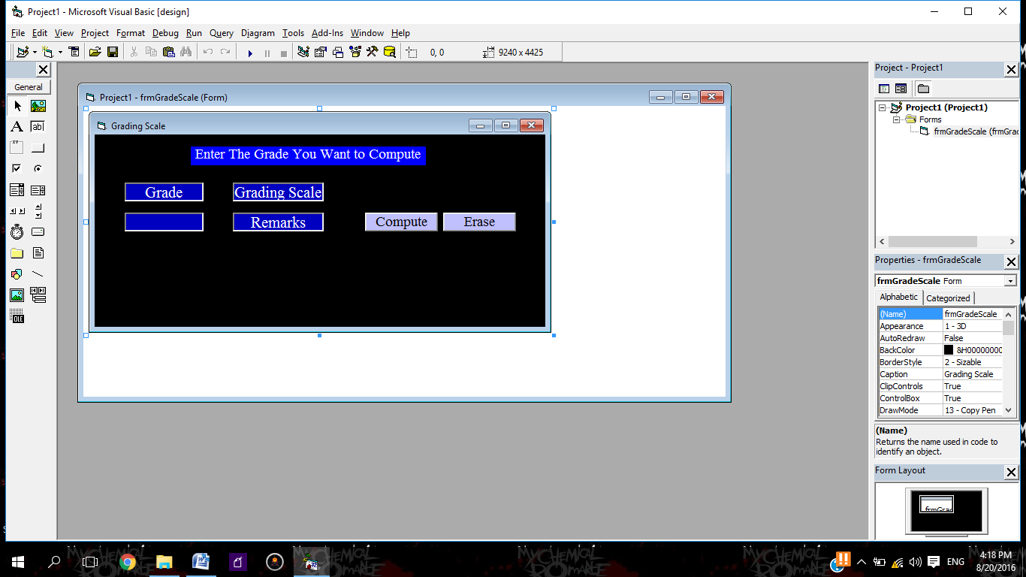**INTERFACE:**

**CODES:**

**Private Sub cmdCompute_Click()**

**Dim Grade As Single**

**Dim Remarks As Single**

**Grade = Val(txtGrade.Text)**

**If Grade = 90 Then**

**lblRemarks.Caption = "A"**

**End If**

**If Grade >= 88 And Grade <= 89 Then**

**lblRemarks.Caption = "B+"**

**End If**

**If Grade >= 80 And Grade <= 87 Then**

**lblRemarks.Caption = "B"**

**End If**

**If Grade >= 78 And Grade <= 79 Then**

**lblRemarks.Caption = "C+"**

**End If**

**If Grade >= 0 And Grade <= 69 Then**

**lblRemarks.Caption = "D"**

**End If**

**If Grade > 90 Or Grade < 0 Then**

**lblRemarks.Caption = "Invalid"**

**End If**

**End Sub**

**Private Sub cmdErase_Click()**

**txtGrade.Text = ""**

**lblRemarks.Caption = "Remarks"**

**End Sub**

**PROBLEM #2**

**For any number in the range 0-500 determine the quality of the value according to the following table:**

**0-125 Marginal**

**126-385 Acceptable**

**386-415 Well Above Average**

**416-500 Exceptional**

**For output display the range for the category of the value entered and its value.**

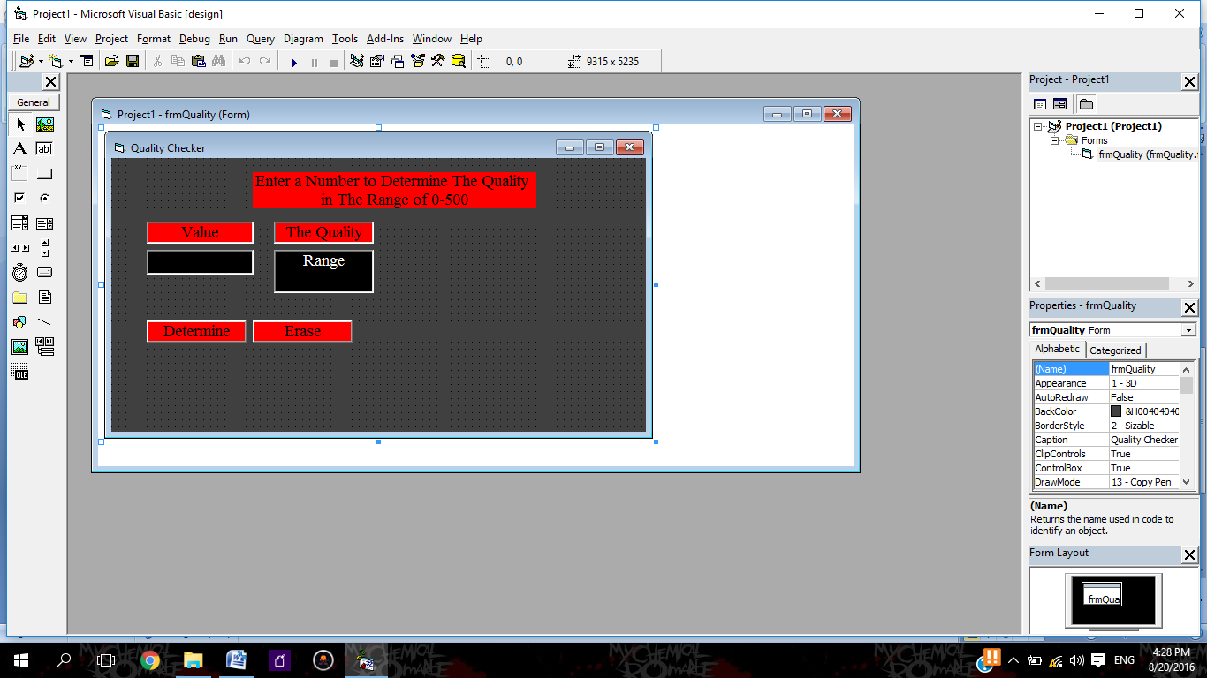**INTERFACE:**

**CODES:**

**Private Sub cmdDetermine_Click()**

**Dim Value As Single**

**Dim Range As Single**

**Value = Val(txtValue.Text)**

**If Value >= 0 And Value <= 125 Then**

**lblRange.Caption = "Marginal"**

**End If**

**If Value >= 126 And Value <= 385 Then**

**lblRange.Caption = "Acceptable"**

**End If**

**If Value >= 386 And Value <= 415 Then**

**lblRange.Caption = "Well Above Average"**

**End If**

**If Value >= 416 And Value <= 500 Then**

**lblRange.Caption = "Exceptional"**

**End If**

**If Value > 500 Or Value < 0 Then**

**lblRange.Caption = "Invalid"**

**End If**

**End Sub**

**Private Sub cmdErase_Click()**

**txtValue.Text = ""**

**lblRange.Caption = "Range"**

**End Sub**

**PROBLEM #3**

**An aptitude test has two parts. The score in each part range from 0-50. Enter a person’s scores on each part and determine the evaluation given by the following table where the Part I score is given if the Part II score is above the range for that Part I score.**

**Part I Part II Evaluation**

**0-20 0-10 Retake in 30 days**

**21-35 11-25 Take practical test**

**36-50 26-50 Certification completed**

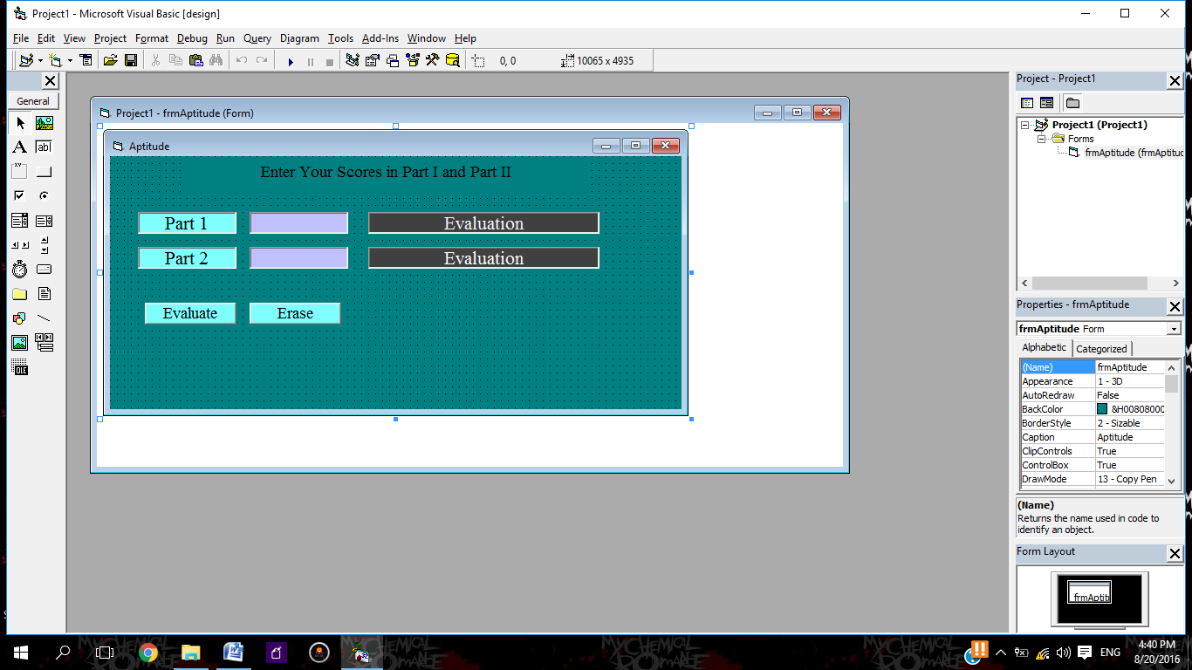**INTERFACE:**

**CODES:**

**Private Sub cmdEvaluate_Click()**

**Dim Var1 As Single**

**Dim Var2 As Single**

**Dim Eval1 As Single**

**Dim Eval2 As Single**

**Var1 = Val(txtVar1.Text)**

**Var2 = Val(txtVar2.Text)**

**If Var1 >= 0 And Var1 <= 20 Then**

**lblEval1.Caption = "Retake in 30 Days"**

**End If**

**If Var2 >= 0 And Var2 <= 10 Then**

**lblEval2.Caption = "Retake in 30 Days"**

**End If**

**If Var1 >= 21 And Var1 <= 35 Then**

**lblEval1.Caption = "Take Practical Test"**

**End If**

**If Var2 >= 11 And Var2 <= 25 Then**

**lblEval2.Caption = "Take Practical Test"**

**End If**

**If Var1 >= 36 And Var1 <= 50 Then**

**lblEval1.Caption = "Certification Completed"**

**End If**

**If Var2 >= 26 And Var2 <= 50 Then**

**lblEval2.Caption = "Certification Completed"**

**End If**

**If Var1 > 50 Or Var1 < 0 Then**

**lblEval1.Caption = "Invalid"**

**End If**

**If Var2 > 50 Or Var2 < 0 Then**

**lblEval2.Caption = "Invalid"**

**End If**

**End Sub**

**Private Sub cmdErase_Click()**

**txtVar1.Text = ""**

**txtVar2.Text = ""**

**lblEval1.Caption = "Evaluation"**

**lblEval2.Caption = "Evaluation"**

**End Sub**